STUDY GUIDE #2

English Foundations in America
As of 10/15/07
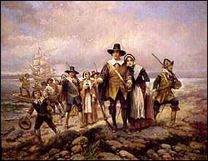

People
John Smith
John Rolfe
Lord DeLaWarre
Opechancanough
Powhatan
Pocahontas
Nathaniel Bacon
Powhatan confederacy
“Sea Dogs” or privateers

Other Terms of Note
1st and 2nd Powhatan Wars
Indentured Servant
House of Burgesses
Jamestown, Virginia
Virginia Company of London
Virginia Company of Plymouth
Tobacco
Shaman
“Irish Tactics”
Bacon’s Rebellion
Church of England (Anglican)

Things to think about
• Differences between English and Spanish race relations.
• Why did colonists choose the locations for Jamestown and Plymouth?
• How did plague and disease affect the Native power structure?
• Explain how class differences in early Virginia led to outright revolt.

