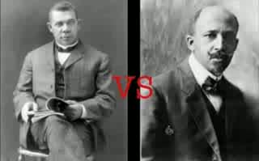
Study Guide
Broken Promises Unit

People
Andrew Johnson
the Radical Republicans
the original Ku Klux Klan
the White Leagues
Ulysses S. Grant
the Freedmen
Herman Plessy
Booker T. Washington
George Washington Carver
W.E.B. DuBois
Jack Johnson
the new Ku Klux Klan
Marcus Garvey
the Tuskegee Airmen

Events & Places
Reconstruction
13th, 14th, & 15th Amendments
Original Mardi Gras Krewes
Freedmen’s Bureau
Force Act
Compromise of 1877
Plessy v. Fergusson
Niagara Conference
Atlanta Compromise
Brown v. Board of Education
Harlem Renaissance
Bronzeville
Great Migration
Chicago Race Riot of 1919
East Saint Louis Race Riot
Birth of a Nation

Concepts
Carpetbaggers
sharecropping & tenant farming
Jim Crow laws
segregation
Social Darwinism
“Separate but Equal”
“passing”
“One Drop” Rule
grandfather clauses, poll taxes, & literacy tests
Tuskegee Institute
NAACP (Nat’l Association for the Advancement of Colored People)
“Great White Hope”
New Negro Movement
UNIA (Universal Negro Improvement Association)
Pan-Africanism

Think About
• How successful was Reconstruction?
• How did sharecropping differ from slavery?
• What made Johnson such a lousy president?
• How did whites in the South attempt to maintain control during Reconstruction?
• Why did Republicans agree to end Reconstruction?
• What were the impacts on African Americans when Reconstruction ended?
• What were the reactions of African-Americans to reactionary white movements?
• How was Jim Crow made more permanent?
• compare and contrast Washington’s views with DuBois’s views
• Why did people like Jack Johnson have such a different attitude toward Jim Crow than older generations?
• What were the push and pull factors leading to the Great Migration?
• What sort of challenges faces African Americans who moved north?
• How was the second KKK different from the first KKK?
• How were African Americans kept from voting?
• Why was Marcus Garvey so popular?
• Compare different responses African Americans had toward segregation in the early 1900s.

