STUDY GUIDE #4

World War IV: It’s the oil!

As of 5/15/06 As of 5/22/06
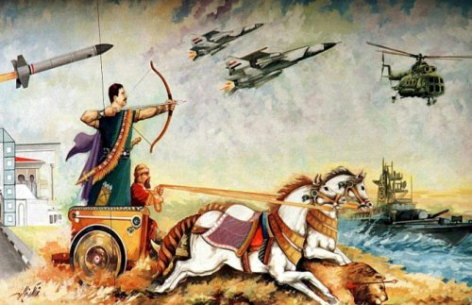
Pro-Saddam Hussein propaganda.

Vocab: Terms & People
Oil Concessions
Fossil Fuels, Petroleum
Muhammed Mossadeq
Operation Nojeh
Operation Ajax
James E. Carter
William D’Arcy
Anglo-Iranian Oil Company (BP)
OPEC
Saddam Hussein
Shariah
Ayatollah Seyyed Khomeini
King Saud
Iran-Iraq War
Shah Reza Pahlavi
Gulf War, 1991
Ronald Reagan
Shi’ia and Sunni Islam
Zionism
Crisis of Confidence Speech, 1979
Iran Hostage Crisis, 1980
Soviet Invasion of Afghanistan, 1979
Formation of Israel, 1948
Six Day War, 1967
Henry Kissinger
Porifiro Diaz
Pemex
Palace Coup
rhetoric
Balfour Declaration
Camp David Accords, 1978
Rockefeller Republicans
Palace Coup
Dick Cheney
King Farouk
Gamal Abdul Nasser
Donald Rumsfeld
British Mandate
Amin al-Husayni
Arab League
Mujahideen
Al-Qaeda
Osama bin Laden
George Herbert Walker Bush
Arab (as an ethnicity)
Ottoman Empire
Suez Crisis
Sinai Peninsula
King Hussein
Munich Olympics, 1972
al-Fatah
Hamas
Yasser Arafat
Black September
Yom Kippur War, 1973
Oslo Accords, 1993
Intifada, 1987 & 2000
SCUD missiles
Balance of Power
Republican Guard
April Glaspie
Babylonian rhetoric
Desert Storm (Gulf War)
UNSCOM
“Shock and Awe”
Abu-Gharib scandal
Abu-Musab al-Zarqawi
Mahmoud Ahmadinejad

Things to think about
What affects the price of oil?
Consequences of Saud/FDR meeting.
Effects of Oil Shortages
Was Carter asking too much?
Comparison of rhetoric
Case of the Missing Barzanis
British activities in Middle East
Hot war between Arabs and Zionists
Should history be forgotten about for peace?
Iran’s reaction to Sadat’s death
World reaction to Israel’s raids in Iraq
Balance of Power theory in MidEast
Why anti-American sentiment in MidEast?
What is Iraq’s problem with Kuwait?
World reaction to Israeli reactor raid in 1981
Why end the Gulf War when it did?
Terms of Gulf War withdrawal
Effects of Vietnam Syndrome on Bush’s approval
How did Pres. Bush deal with 9/11?
“Why do they hate us?” by Zakariah

Case Studies
Iran, Iraq, Israel, Saudi Arabia, Egypt, Mexico, Kuwait, Jordan

