STUDY GUIDE #2

International Power Politics

As of 2/6/06 As of 2/22/06
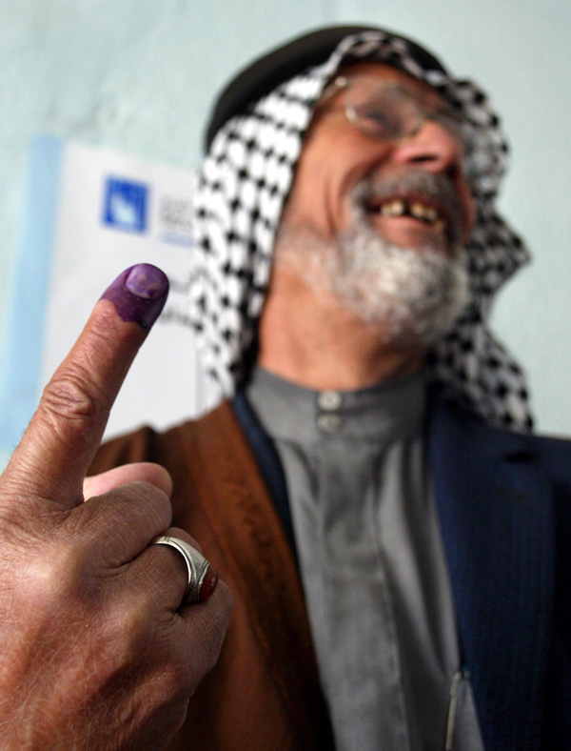
An Iraqi man shows off an ink-stained finger after casting a ballot outside Baghdad. (State Dept. Photo)

Vocab: Terms & People

Empire
Georg Lukacs
Cultural Homogeny
Political Homogeny
Cold War
Sanctions
Woodrow Wilson
George W. Bush
Free Trade
Isolationism
Hegemony
Hegemon
Unilateralism vs. Multilateralism
Isolationism vs. Internationalism
Washington’s Farewell Address
Nuclear Proliferation
Hull vs. Bender
3 Necessities for Nuclear Deterrence
Credibility
Rationality
Mutually Assured Destrction
Cuban Missile Crisis
Manhattan Project
J.R. Oppenheimer
Harry S. Truman
Fidel Castro
Henry L. Stimson
Nikita Kruschev
“Axis of Evil”
rogue states
Tsar Bomb “Ivan”
Hiroshima and Nagasaki
Ballistic missile
Non-Proliferation Treaty of 1968
Non-state actor
North Korea
Kim Il-Sung and Kim Jong-Il
Iran in the nuclear game
Cartoon riots of 2006
3 Ways to Exert Power
Power Politics
Deterrence
Al-Qaeda
Bush Doctrine
Condaleeza Rice
Bargaining
1989 & 1992 significance in power pols
1945 significance in power pols
Cold War

Things to think about

Role of the U.S. in world
Lukacs 1919 theory of hegemony
Differing ways dominance can occur: (Social, Political, Economic)
Big Powers vs. Middle Powers
Trouble with nuclear deterrence
The birth of U.S. hegemony
The effects of the Cold War
Worldwide criticisms of U.S. hegemony
Is the U.S. an empire?

