STUDY GUIDE #1

The International Media

As of 1/20/06
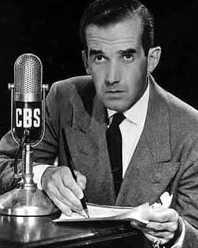
“No one can eliminate prejudices—just recognize them.” Edward R. Murrow (above)

Vocab: Terms & People

Medium
Slant
Gatekeeper
Shortwave Radio
Al-Jazeera
Synergy
Value Judgement
Elite Media
First Amendment
Media Literacy
Public vs. private media
Hype
Wire Service
Major Media Corporations

Things to think about

How news stories are formed
Types of news media
Human needs the media meets
Role of news media in democracies
Worldwide literacy and media graphs

Questions
Note that all daily questions fit into this category.
Where does slant come from?

