STUDY GUIDE #4

The Cold War in Europe & Beyond

As of 4/21/06 As of 5/1/06
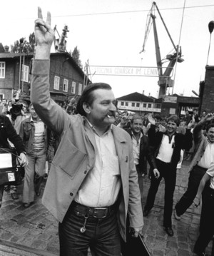
“He who puts out his hand to stop the wheel of history will have his fingers crushed.” Lech Walesa (above)

Vocab: People & Places
John Paul II
Lech Walesa
Solidarity
Leonid Brezhnev
Nikita Kruschev
Mikhail Gorbachev
Jozef Stalin
Ho Chi Minh
Mahatma Gandhi
Marshal Tito
Hiroshima & Nagasaki
Margaret Thatcher
Charles de Gaulle
Ronald Reagan
Boris Yeltsin
Slobadon Milosovic
Vladimir Putin

Vocab: Terms & Events
Berlin Wall
United Nations
Nuremburg Trials
Marshall Plan
Berlin Blockade
Warsaw Pact
Cuban Missile Crisis
Decolonization
Soace Race
Brighton Bombing
Iron Curtain
Common Market
Containment
Glastnost
Perestroika
European Union
Battle of the Falkland Islands
Non-Proliferation Treaty of 1968
SALT I & II
Sputnik
Central Intelligence Agency
State Security Committee (KGB)
North Atlantic Treaty Organization
August Coup
Munich Olympics
Euro
Youth Revolution
Fifth Republic
Chernobyl

Things to think about
How did Solidarity contribute to the end of the Cold War?
Vietnam and France
Nuclear proliferation and its consequences
How did the Missile Crisis change U.S./Soviet relations?
How did European boundaries change in the 1990’s?

Coverage
McKay: Chapter 28-29

ALSO INCLUDE ANYTHING HIGHLIGHTED IN YOUR MCKAY BOOK!

