STUDY GUIDE #3

World War 2

As of 4/21/06
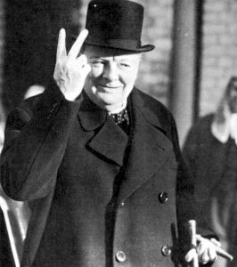
“A fanatic is one who can’t change his mind and won’t change the subject.” Winston Churchill (above)

Vocab: People & Places
Adolf Hitler
Winston Churchill
Franklin D. Roosevelt
Francisco Franco
Erich Ludendorff
Paul von Hundenburg
Alfried Krupp
Fritz Thyssen
Benito Mussolini
Jozef Stalin
Walter Rathenau
Spatikusbund
Friedrich Ebert
Gustav Stresemann
Heinrich Bruning
Winston Churchill
Neville Chamberlain
Charles de Gaulle
German Worker’s Party (DAP)
National Socialists (Nazis)
Sudetenland
Reichstag
Nagasaki & Hiroshima

Vocab: Terms & Events
Kapp Putsch
Weimar Republic
Treaty of Rapallo
fascism
Spartacist Uprising
Occupation of the Ruhr
Dawes Plan
Young Plan
Munich Pact
Enabling Act
Fuhrer
Anti-semitism
Operation Overlord
Polish Invasion
Battle of Britain
Battle of the Bulge
Non-Aggression Treaty
Operation Barbarossa
Beer Hall Putsch

Things to think about
Effects of hyperinflation in pre-war Germany
How did the junkers & business class support Hitler
Why was Hitler appointed chancellor?
Why did Allies react so slowly to Nazi expansionism?
What made Europe ripe for fascism in the 1930’s
What kinds of propaganda techniques were used by Nazis

Coverage
McKay: Chapter 28-29

ALSO INCLUDE ANYTHING HIGHLIGHTED IN YOUR MCKAY BOOK!

