It is unfair for historians to label Christopher Columbus among the “scoundrels” of history. More than anything, Columbus was simply a product of his time and actually represented the majority view of his own culture. He was not without principles, as a scoundrel, by definition, is. His principles were simply different than those of our own time.
Example of a 5/5 Question of the Day
Answer the question directly and right away in the first sentence. Take a stand/position.
Explaining the way you are going to prove your position is a the best way to end the first paragraph.
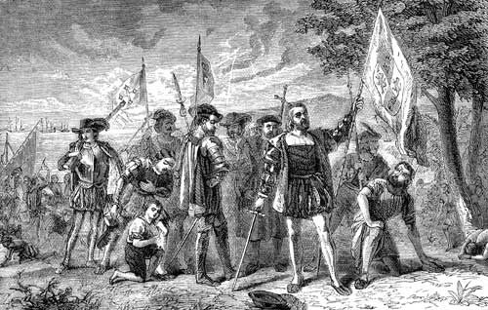
Consult the Skeleton! In a regular essay or DBQ you would actually write a very different kind of first paragraph. If the essay is a marathon, a QoD is simply an exercise: a jog around the block.
Every paragraph should begin with a topic sentence that explains the argument made in that paragraph.
Columbus’ 15th century Spanish-Catholic principles were never abandoned on his journey. They were violent and religious. When he arrived in America, Columbus’ journals focused on the Christianization of the native people he met. His violent methods for introducing Chrsitianity may not mesh well with today’s, but perfectly reflected the methods being used in Spain. Spain recently evicted the Muslim Moors from their homeland in a violent, religious Crusade and was unifying under the violent, religious policy of Inquisition. Columbus was simply reflecting the country from which he came.
Avoid blanket statements. Qualify every position and piece of evidence with real proof from real history. Mention events and names specifically while explaining how your evidence proves your thesis in the first sentence.
Every paragraph contains one idea. Not two ideas. One idea.
Columbus’ principle of Spanish national glory was also never compromised. He represented a country in an expensive arms race. His focus on the attainment of gold, no matter the cost, was a reflection of the policies of Ferdinand and Isabella. The Spanish king and queen were finishing an expensive 700 year-long war and were surrounded by enemies like France and England. It was important to his investors that Columbus returned with wealth and Columbus probably awaited a violent death if he failed. This is why he was so quick to create such a bloody policy of gold mining in America. For Columbus, it was a matter of life and death for his country and for himself. It, naturally, became a matter of life and death for the Indian people he felt he was justified in enslaving.
This second paragraph is a bit weaker since it relies on a general argument rather than a specific one, but it still makes connections and gives an example from history. It also remains focused on the thesis in the first paragraph.
The tone of this example is always ACADEMIC and professional sounding.

