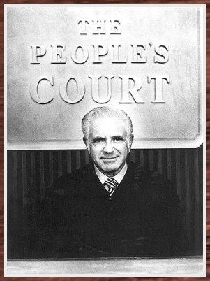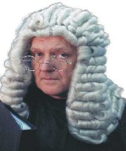

History Court briefing
Case: Native America (plaintiffs) v. Christopher Columbus & the Pinzon Brothers (defendants)

Complaint: Native America claims that Columbus, starting with the Taino, destroyed their lives when he and those who came after he moved in . They say he’s been nothing but trouble: instituting slavery, class struggle, racism, colonialism, disease, and worse. They say only the Europeans benefited from the “discovery.” They feel Columbus and crew are a menace whose names should be cursed.
Defendants: Columbus and the Pinzons, maintain that they were great explorers who found a new continent and set new ground and are heroes. Claim that because of them everyone benefits: the Spanish get much needed cash while the natives have gained eternal life and a great place to work. Without him, Columbus claims, the Natives would never have benefited from the Columbian Exchange or the modern world.

Charge: Robbery, trespassing, slaving, & genocide. Suing for: Columbus’ good reputation.

Cast:

The judges:
• Head judge & three co-judges (For homework you are to research each group and write three facts, at least, on who they are and what their points of view might be. Write four questions for each potential witness and those in court For extra credit, bring in a primary source to be an exhibit in our case.)

The Plaintiffs & Defendants: (For homework you are to research the assigned person and write four main points that help prove their case. Decide which witnesses will be most favorable for your case and list whoyou would call to the stand. For each potential witness group record two questions you might ask to help your case. For extra credit, bring in a primary source to be an exhibit of your case.)
• Taino chief, woman, Arawak miner.
• Christopher Columbus, Martin Alonso Pinzon, Vincente Yanez Pinzon

Witness Groups (character witnesses or eye-witnesses): (For homework you are to research the assigned person and write five facts about the person relevant to the case. Also write three points that describe their point of view about Columbus and three points about the natives. Become an expert on your person because you will be called to the stand. For extra credit, bring in a primary source relating to your testimony.)
• Their eternal Catholic highnesses Ferdinand & Isabella & Torquemada.
• African slaves, working in a sugarcane plantation.
• The Pope Alexander VI & his excellent Cardinals.
• Fr. Bartolome de las Casas & liberation theology missionaries.
• Montezuma & the Aztecs.
• Hernan Cortes, Ponce de Leon, & Francisco Pizzarro.

Sequence (Judge always can interrupt, rule questions unfair, and ask questions whenever)
1.) Opening Statement (Complaint)
2.) Judges Question Plaintiff
3.) Opening Statement (Defense)
4.) Judges Question Defendant
5.) Plaintiffs present witnesses and ask them questions
6.) Defendants have right to cross-examine any of plaintiff’s witnesses
7.) Defendants present witnesses and ask them questions
8.) Plaintiffs have right to cross-examine any of defendant’s witnesses
9.) Judges makes Final Comments and ask final questions before ruling
10.) Ruling is presented.

Other Rules: Everyone is expected to say something at some point. Be serious about this even though it is very fun. There is a classwork grade for this as well as a homework grade. Be sure to do your homework or the classwork grade will suffer dramatically. There will be a bit of time for group planning in school. You are to pay attention to teacher and judges at all times. This is for review so don’t be afraid to take notes about the characters… they are all fair game on the test.

