2009-10 Constitution Test

1.) The first government of the United States operated under which of the following documents?
A. the Declaration of Independence C. the Constitution
B. the Articles of Confederation D. the Bill of Rights

2.) Total membership in the Senate today is
A. 50 men & 50 women B. 1777 C. 100 D. 435

3.) Why did the U.S. government that existed before the Constitution fail?
A. There was no way to enforce the laws passed by the legislature.
B. It was under constant attack by the British and Indians.
C. Its Northwest Ordinance was a total failure.
D. All of the above.

4.) Which American Indian group inspired the formation of federalism in the U.S. government?
A. the Anasazi B. the Algonquin C. the Iroquois D. the Sons of Liberty

5.) The Constitutional requirement for the age of a Senator is
A. 30 years old B. 25 years old C. 35 years old D. 50 years old

6.) The major duty of the legislative branch is to
A. make the laws B. enforce the laws C. interpret the laws D. choose the Cabinet

7.) The membership of the Senate is based upon
A. equal representation for each state C. population of each state
B. a state’s wealth D. the electoral college

8.) The term of office for a member of the House of Representatives lasts
A. 2 terms B. 2 years C. 4 years D. 6 years

9.) This type of bill can only be introduced in the House of Representatives?
A. revenue (tax) B. education C. energy D. war

10.) The current Speaker of the House is:
A. Nancy Pelosi B. Condoleezza Rice C. Robert C. Byrd D. Dick Cheney
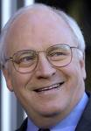

11.) Which is NOT an enumerated power of Congress?
A. collecting taxes B. delivering mail C. Coining money D. appointing judges

12.) Who elects the President and Vice-President of the United States?
A. the people B. the electoral college C. Congress D. rich people

13.) The founding fathers, as they are called, did NOT want a pure democracy because
A. they were fearful of the power it would give poor people who outnumbered the rich.
B. they did not want their government to be modeled after the failed British government.
C. they felt that pure democracy was best for protecting their right to Liberty.
D. democratic governments tend to be unpopular and tyrannical.

14.) A republican form of government is one in which
A. people directly vote on the most important decisions being made in a country.
B. people elect leaders who represent make decisions on their behalf.
C. a king or dictator administers the entire government.
D. the Democratic party is out of power.

15.) The presiding officer of the House of Representatives is
A. President Pro-tempore C. Vice-President
B. Majority leader D. Speaker of the House

16.) Which of the following is NOT one of the rights given by God according to philosopher John Locke?
A. life B. liberty C. pursuit of happiness D. property

17.) One way the President can check the power of Congress is by
A. appointing Supreme Court justices.
B. withholding funding and money for projects.
C. impeaching members of Congress.
D. vetoing bills that pass the Senate and House of Representatives.

18.) Before a bill is brought before the full house of Congress for a vote, it is perfected in
A. the Cabinet B. the House C. committees D. the Library of Congress

19.) Because of the term limit amendment added to the Constitution in the 1950’s, this is the maximum number of years any one elected President can serve?
A. four B. eight C. unlimited D. twelve

20.) This is the number of terms that a member of the House or Senator can serve?
A. four B. eight C. unlimited D. twelve

21.) The current Secretary of State and fourth in line for the presidency is:
A. Michael Chertoff B. Hillary Rodham Clinton C. Henry Paulson D. Robert Gates
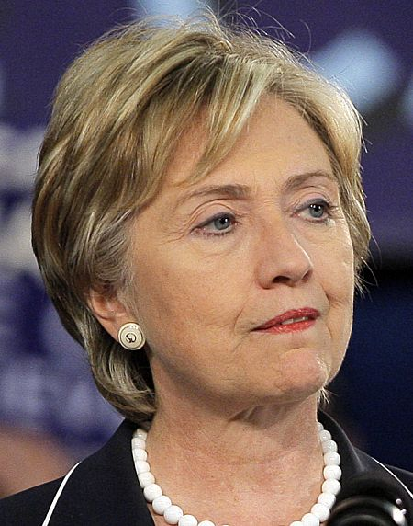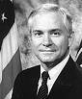

22.) Those who run the departments of the executive branch and act as advisors to the President are called
A. the Cabinet. B. Supreme Court. C. news media D. Congress

23.) An idea for a law is called a(n) ________, and can only be introduced by a member of Congress.
A. proposal B. committee C. bill D. preamble

24.) Laws have no power over the people and are not usually followed without a(n) __________.
A. executive branch B. Supreme Court C. Congress D. veto

25.) When the president vetoes a bill that has passed both house of Congress, Congress can override the veto with
A. 4/5 vote B. 2/3 vote C. majority vote D. they cannot

26.) Which of the following people is eligible to run for President?
A. Frank is a 41 year old lawyer and was born in Santiago, Chile.
B. Angela is a 36 year old student and was born in Gary, Indiana.
C. Pat is a 33 year old farmer born in Baltimore, Maryland.
D. Jean is a 65 year old bus driver born in Toronto, Ontario.

27.) Which of the following people is eligible to run for Senate in Illinois?
A. Jack is 36, lives in Chicago, was born in Egypt, and became a citizen six years ago.
B. Jessica is 42, lives in New York, was born in Chicago, and is a natural-born citizen.
C. Rodrigo is 31, lives in Niles, IL, was born in Cuba, and was naturalized in 1981.
D. Dontrell is 29, lives in Arlington Heights, IL, and was born in Norfolk, VA.

28.) Representation in the Senate favors the
A. Northern states B. Southern states C. Big states D. Small states

29.) Members of the House and the Senate are elected by
A. the popular vote B. state legislatures C. political parties D. the President

30.) The Constitution says that a president can be removed from office if they are found guilty of
A. treason B. “high crimes” C. taking bribes D. all of these

31.) Which of the following people represents Illinois in the Senate?
A. Jan Schakowsky B. Richard Durbin C. Patrick Quinn D. John Roberts
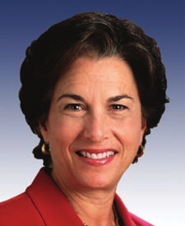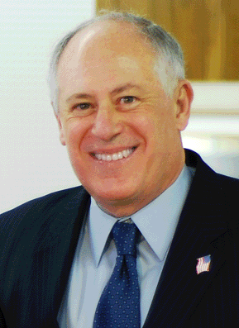

32.) Although the Vice-president is leader of the Senate, when he is not around, the Senate is led by
A. President Pro-tempore C. Vice-President
B. Majority leader D. Speaker of the House

33.) The justices of the Supreme Court serve a term that lasts _____ .
A. 4 years B. 10 years C. 6 years D. life

34.) Officials of the federal government receive payment for their services because?
A. They are greedy. C. Pay discourages bribing.
B. What they do is hard work. D. They collect taxes.

35.) Justices of the Supreme Court are chosen by
A. the House of Representatives C. the Senate
B. the President D. the popular vote

36.) Which ranks as the highest law?
A. the Constitution B. state laws C. local laws D. federal treaties

37.) The number of electors in the electoral college for each state is equal to the number of a state’s
A. Senators and House members C. Senators and Governor
B. male population D. counties

38.) This is the name for the first paragraph of the Constitution which outlines its goals.
A. elastic clause B. preamble C. thesis D. opener

39.) The best definition of the word “amend” is
A. to approve B. to veto C. to declare unlawful D. to add or change

40.) “Checks and balances” refers to a device in the Constitution that
A. keeps one branch of government from becoming too powerful
B. bank accounts kept by the Secretary of the Treasury
C. keeps one state from becoming more powerful than another
D. Mr. Plencner combing his hair every morning.

Part II: Name the Branch (15 points, 1 each)
Directions: On your answer sheet mark the letter of the branch of government involving each statement.

a) Legislative b) Executive c) Judicial

41) This was laid out in Article 1 of the Constitution.
- This branch carries out the laws of the nation and makes sure everyone follows them.
- The F.B.I., C.I.A., National Weather Service, and N.A.S.A. are all a part of this branch.
- This branch has the power to declare war.
- The body that passes laws and taxes in Great Britain.
- Members of this branch are appointed by the President and then approved by the Senate.
- This branch is bicameral.
- Members of this branch serve until they die or resign.
- Members of this branch meet with visiting foreign leaders.
- This branch sentences people accused of federal crimes like drug trafficking.
- This branch is laid out in Article 3 of the Constitution.
- Its leader is currently George W. Bush.
- This branch is laid out in Article 2 of the Constitution.
- This branch hears federal cases and answers Constitutional questions.
- Includes the Army, Navy, and Air Force.

