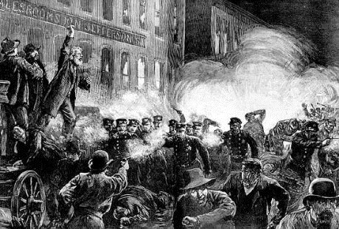Study Guide #4
Chaos and Disorder in the Gilded Age

Labor Theory
Capital
Capitalism
Wage Slavery
Communist Manifesto
Karl Marx
The 1848 Revolutions
Mikhail Bakunin
Socialism
Anarchism
Labor Movement
Plutocracy
Labor union
Collective Bargaining
Strike
Scabs
Sympathy Strikes
Terrorism

Labor in the U.S.
Monopoly:
Vertical Integration
Horizontal Integration
J.P. Morgan
Andrew Carnegie
Tycoons
Terence Powderly
Sam Gompers
American Fed. of Labor &
Congress of Industrial Unions
(AFL-CIO)
IWW (a.k.a. “Wobblies”)
Homestead Strike (in PA)

Labor in Chicago
Great Railroad Strike of 1877
Albert Parsons
Lucie Parsons
August Spies
Gen. Phil Sheridan
Mayor Carter Harrison Sr.
Gov. John P. Altgeld
George M. Pullman
Pullman Sleeper Cars
Pullman Neighborhood
Social Engineering
Pullman Strike of 1894
Eugene V. Debs
American Railway Union
Pres. Grover Cleveland
Richard Olney
German Immigrants
Haymarket Riot
Haymarket Trial & Pardons
Transit Strike of 1885
The Pinkertons
Role of Chicago Police Dept.
Role of Chicago Tribune
Arbeiter-Zeitung newspaper
Alan Pinkerton
Panic of 1893
Labor Day proclamation

Things to Review
City of the Century film clips
Pacyga pp. 84-99, 121-125, 143-7
Class notes
QoDs and Opens

- Why did capitalists feel they had the right to control their money and means of production?
- Why were German immigrants particularly blamed for labor issues?
- Why did Pullman’s experiment fail?
- Why did labor struggles often turn violent?
- Why would a boss want to avoid a strike?
- Why did the Pullman Strike require the President’s involvement?
- How are sympathy strikes especially effective for unions?
- What was Pullman’s idea about how to solve the labor problem?
- How were the Chicago Police often caught in the middle of warring factions?
- What was the reaction to the Haymarket Affair?
- Why was Pullman found to be “un-American” by the U.S. government?
- How and why was the American labor movement less radical than the movement in Europe?

