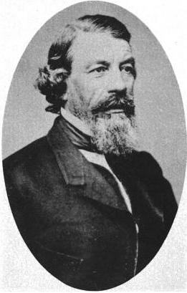
Study
Guide #2
Indian Removal & the Birth of the Wheat-Stacker

People to Know
Tecumseh & the Prophet
John Kinzie
Shabonna
Pottawatomie
Simon Pokagon
Juliette Kinzie
Blackhawk
Billy Caldwell “Sauganash”
Alex. Robinson “Chechepinqua”
Gurdon S. Hubbard
William Butler Ogden
William Gooding
Irish & German immigrants
Cyrus H. McCormick
John Deere
Stephen A. Douglas

Places to Know
Indian Boundary Line, 1816
Old Northwest
Fort Dearborn
The State of Illinois, 1818
Illinois & Michigan Canal
Mud Lake Crossing

Events to Know
Northwest Ordinance
Tecumseh’s War
War of 1812
Chicago Land Rush
Fur Trade
Fort Dearborn Massacre
Potato Famine
Blackhawk War

Things to Know
Indian Removal Policy
American System
Land Sales & Surveys
Treaty of Greenville, 1795
Treaty of Chicago, 1833
Treatment of immigrants
Building of railroads
Hub
Building of canals
Canal Scrip (I.O.U.’s)
Steel plow
Mechanical Reaper
Grain Elevator
Truck farming
hustler
“Stacker of Wheat”

Economics to Know
Chicago Board of Trade
Futures Contract
Supply and Demand
Commodity
To hedge
Computer-based trading

Things to Review
Prairie Tides film
Floored film
Pacyga’s Chicago Ch. 1
Class notes
QoDs and Opens

- How were immigrants treated and paid?
- Why did the Irish come to Chicago?
- Compare 2 early immigrant groups
- Compare French ideas about land to American ideas
- Explain the futures market
- How was corn liquefied?
- How/why were Native Americans removed?
- How did the Depression of 1837 affect the canal building?
- How did Hubbard’s life change during this era?
- Why did the railroad replace the canal in importance?
- How did Chicago become a city?
- How did the canal work? How did it change the city? The state?
- Why was the I&M built?
- Describe sanitation in Chicago during this era.
- What problems came with such rapid urban growth?

