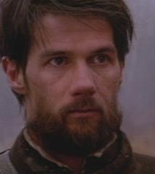
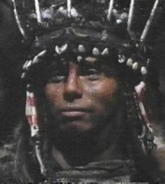
25 Black Robe Questions
- Why did Father Lafourge (the Black Robe) confront the fur trader in Quebec?
- What advice did Champlain (the big guy with the beard) have for Father Lafourge before he sets off into the wilderness?
- Why did Daniel (the young guy) want to come along with Lafourge on the mission into the “wild”?
- In the night party scene, how are the French and the Algonquins similar?
- Why did the Chief Chomina agree to protect Fr. Lafourge?
- Why were birch-bark canoes a great way to travel in the 17th century Midwest?
- How would you feel sleeping the way the Algonquins sleep at night?
- What about the priest in the church inspired Lafourge to become a Jesuit?
- Do the Algonquins respect Fr. Lafourge? What proof do you have?
- How did the Algonquin react to the demonstration of reading & writing?
- Chomina warns his daughter that Daniel is “stupid” and useless as a provider. Is Chomina right?
- How does life as a Jesuit missionary compare to Lafourge’s life in France?
- How did the Algonquin leader Chomina make important decisions?
- Why did the Algonquin come to see Mestigoit, the Montagnis sorceror?
- Is Mestigoit threatened by Fr. Lafourge in some way?
- How does Lafourge react to being lost in the woods? How do the Algonquin react to Lafourge losing his way?
- Who reacted better to being left: Lafourge or Daniel? Why?
- What weapon was better: the bows or the gun? Why?
- How do the Iroquois deal with captured enemies? Why do you think they acted this way?
- How are the Iroquois depicted differently from the Algonquin?
- How do the characters deal with the cold winter?
- How does Lafourge deal with the fact Daniel wants to leave him?
- What is the condition of the mission when Lafourge finally reaches it?
- What do the Hurons think will happen to them if they become Christians?
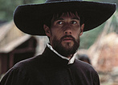
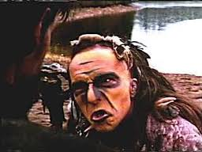
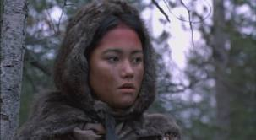
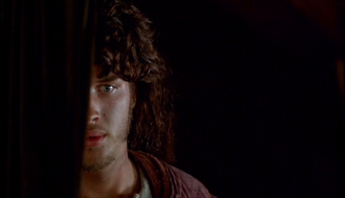
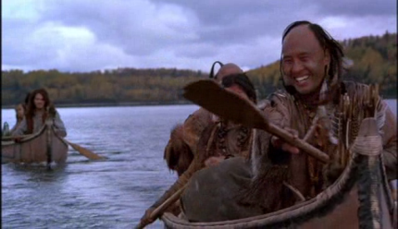
- After all he’s been through, does Lafourge love the Indians? Give proof.

