STUDY GUIDE #8

Oil makes the world go round
As of 5/2/09
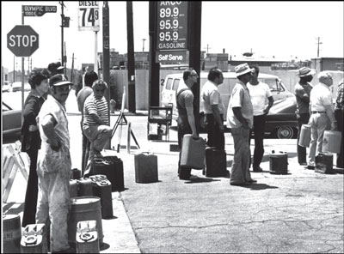
Future Reagan voters stand in line for gas.

People
Ayatollah Ruhollah Khomeini
Shah Reza Pahlavi
Gerald Ford
Jimmy Carter
Ronald Reagan
Arab
King Hussein
Osama bin Laden
George H.W. Bush
Muhammad Mossadeq
William Knox D’arcy
Saddam Hussein
Amin al-Husayni
Gamal Abdul Nasser
Yasser Arafat
Stanley Tookie Williams
Mahmoud Ahmadinejad

Events
Balfour Declaration
Formation of Israel, 1948
Operation Ajax
Suez Crisis
Six Day War
Energy Crisis
Munich Olympics, 1972
Yom Kippur War, 1973
Alaska Pipeline
Election of 1976 (Ford v. Carter)
Camp David Accords
Malaise “Sweater” Speech
Soviet Afghan Invasion
Los Angeles Gang War
Black September
Iranian Revolution
Iran Hostage Crisis
Operation Eagle Claw
Election of 1980
Operation Nojeh
Iran-Iraq War
Operation Desert Storm
Oslo Accords, 1993
Intifada, 1987-1993 and 2000-2005
Removal from Gaza, 2005
Gaza Invasion, 2009

Concepts & Terms
Shi’ia Islam (Shi’ites)
Sunni Islam (Sunnis)
OPEC
Inflation & Stagflation
Malaise
Bloods vs. Crips
Mujahideen
Shahada
Shariah
Levant (Palestine/Israel)
Terrorism
Al-Qaeda
Al-Fatah
Black September
Hamas
Poppy Crops
Heroin
Arab League
Anglo-Iranian Oil Company (BP)
“Just Say No”

Countries of Notes
Iran, Iraq, Israel, Saudi Arabia, Egypt, Jordan, Palestine

