STUDY GUIDE #5

Camelot: JFK & the Cold War
As of 1/15/09
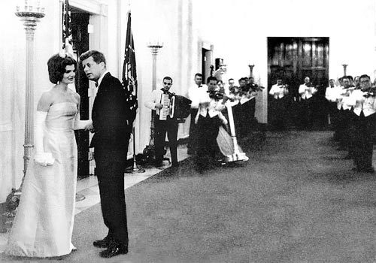
Jack & Jackie at the inaugural ball in 1961.

People & Dogs
John F. Kennedy (Jack)
Robert F. Kennedy (Bobby)
Joseph Kennedy, Sr.
Jacqueline Bouvier Kennedy
Robert McNamara
Fidel Castro
Raul Castro
“Che” Ernesto Gueverra
Yuri Gagarin
John Glenn
Gary Powers
Laika
Fulgencio Batista
Nikita Khruschev
Richard M. Nixon
Lee Harvey Oswald

Events
Cuban Missile Crisis
Bay of Pigs Invasion
Building of Berlin Wall
JFK’s Inaugural Speech
New Frontier
Sputnik Launch
Space Race
Cuban Revolution of 1959
National Defense Education Act
Warren Commission

Concepts & Terms
Nuclear Deterrence
- Rationality
- “Guts”
- 2nd Strike Capability
- Mutually Assured Destruction
Agrarian (Land) Reform
Nationalize (as in industries)
Ballistic missiles
U2
“Moon Goal”
National Aeronautics & Space Administration
Peace Corps
Brinkmanship
Camelot
Hot Line
Flexible Response
Astronaut & Cosmonaut

Questions
• How did Cuba change as a result of the 1959 Revolution?
• How did the USA react to Sputnik?
• What were some ways the USA tried to remove Castro?
• How did Castro anger the US establishment?
• What is so unique about the election results of 1960?
• How did the media affect events during the Camelot era?
• What were some criticisms of JFK as president? What were some of his successes?
• What was the Kennedy mystique?
• Why is the assassination so controversial?

