STUDY GUIDE #4

The Early Civil Rights Movement
As of 12/16/08
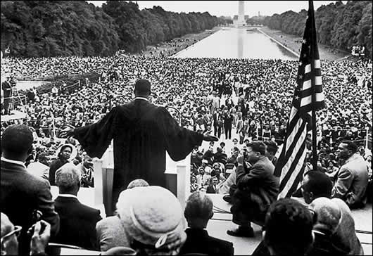
Dr. King delivers his famous “I Have a Dream” speech.

People
Thurgood Marshall
Earl Warren
Mamie Till
Rosa Parks
JoAnn Gibson Robinson
Martin Luther King
“Little Rock Nine”
Orval Faubus
Dwight D. Eisenhower
Nixon vs. Kennedy
“Freedom Riders”
John Patterson
Lyndon B. Johnson
Robert Kennedy
Stokely Carmichael
Malcolm X
George Wallace
Black Panthers
Huey Newton
Bobby Seale
John Lewis (of SNCC)

Organizations
• NAACP (National Association for the Advancement of Colored People)
• SNCC (Student Non-Violent Coordinating Committee)
• SCLC (Southern Christian Leadership Conference)
• CORE (Congress on Racial Equality)
• KKK (Ku Klux Klan)
• White Citizens’ Councils

Events
Brown v. Board of Education of Topeka
Emmett Till Murder Case
Montgomery Bus Boycott
Civil Rights Act
Little Rock Central High School
Sit-ins
Freedom Rides
Birmingham Church Bombing
Selma March
Bloody Sunday
Watts Riots
Chicago Freedom Movement
Voting Rights Act

Concepts & Terms
“Soul Force”
Nonviolence
Civil Disobedience
Police riots
Voter Registration
Literacy tests
Jim Crow
Desegregation/Integration
Segregation
Housing Discrimination
Pettus Bridge
National guard

