STUDY GUIDE #3

HappyDays? 1950s Consumerism
As of 11/18/08
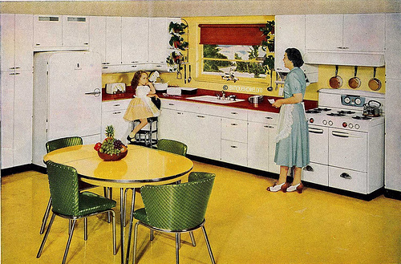
A housewife “enjoys” her brand-new kitchen!

The Suburbs & Cars
Suburbs
G.I. Bill
Baby Boom
McDonald’s (fast food)
Shopping Malls
Satellite Business District
Interstate Highway Act
Family Road Trip
Uniformity
Sunbelt
Dwight D. Eisenhower
Eminent domain

• What was the change in the model city?
• What role did transportation play in the new city?
• Why did suburbs appeal to WW2 veterans?
• Why was the automobile increasingly important?
• How did people adapt to suburban culture and isolationism?
• How did the role of women change in the 1950s?

Business World
Conglomerate
Company/Organization Men
International Business Machines
Credit card
Diner’s Club

Hyper-Marketing
Marketing *
Media Conglomerate *
Viacom *
“Cool-hunting” *
Television Ownership
Teen-ager
Race Music
Authenticity
Rock’n’Roll
Call & Response
Big Joe Turner
Elvis Presley

• What was the real purpose of television?
• How did marketing change in the 1950s?
• What t.v. shows were most popular?
• Who invented the “teen-ager?”
• How did rock music lose its authenticity?
• Did rock music bring racial understanding or drive a wedge between blacks and whites?
• How did consumption in the 50s compare with previous decades?

Women’s Status
Betty Frieden
Brownie Wise
Hugh Hefner
Benjamin Spock
Housewife
Tupperware marketing system

• How did depictions of women in the media change in the 1950s?
• What problems with women’s roles did Frieden see in her research?
• Did the role of women really change in the ‘50s?

* consumer education info

