STUDY GUIDE #2

Cold War Origins
As of 10/29/08
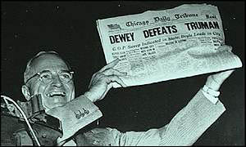
Truman knows not to put too much stock in polls.

People & Organizations
Karl Marx & Friedrich Engels
Vladimir Lenin
Jozef Stalin
Harry S Truman
Joseph McCarthy
Screen Actors Guild (SAG)
United Nations (UN)
HUAC
Richard M. Nixon
Douglas MacArthur
Albert Einstein
NATO
Warsaw Pact
George Kennan
Margaret Chase Smith
Ronald Reagan
Kim il-Sung
Mao Tse-Tung
Chiang Kai-shek
J. Strom Thurmond
Jacobo Arbenz
Central Intelligence Agency (CIA)
Nikita Kruschev

Places and Events
Yalta Conference
Potsdam Conference
Berlin Blockade
Berlin Airlift
Korean War
Manhattan Project
Hiroshima & Nagasaki
Marshall Plan
Molotov Plan
Election of 1948
Kitchen Debate
Guatemala 1953

Other Terms of Note
red scare
proxy war
iron curtain
communism
redistribution
public ownership of property
treason
witch hunt
land reform
“pinko” & “red”
nuclear weapon
arms race
Truman Doctrine
containment
fallout shelter
Communist Manifesto

