STUDY GUIDE #1

Changing Homefront during WW2
As of 09/29/08
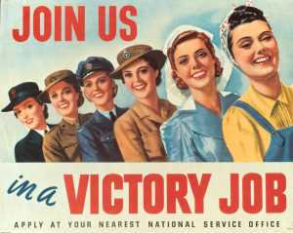
Every American was invited to help the war effort.

People & Organizations
Franklin D. Roosevelt
Adolf Hitler
National Socialist Party
Axis Powers
Jozef Stalin
Walt Disney & Donald Duck
America First Committee
Charles Lindbergh
Henry L. Stimson
Booker T. Washington
W.E.B. du Bois
Tuskegee Airmen
Eleanor Roosevelt
Negro Leagues
NAACP
Jackie Robinson
Happy Chandler
Branch Rickey
Joe Louis
Asa Philip Randolph
Tin Tan & Cab Calloway
Chicanos
Pachucos
Fletcher Bowron
Fred Korematsu

Places and Events
Great Depression
New Deal
Neutrality Act
Lend-Lease Act
Sinking of Reuben James
Pearl Harbor
Tuskegee Institute
Plessy v. Fergusson
Truman’s Executive Order 9981
Great Migration
Bloody Week (Detroit)
East L.A.
Mexican Repatriation
Bracero Program
Zoot Suit Riots (L.A.)
Japanese Internment
Korematsu v. United States

Other Terms of Note
Fireside Chats
Fascism
Gulag
Propaganda
Isolationism vs. Interventionism
Rationing
Homefront
Scrapping
Mobilization
Big Government
War Bonds
Black Isolationism
Jim Crow laws
lynching
Segregation vs. Integration
“Separate But Equal”

Some questions
• Why did Japan attack the U.S.?
• Why did the U.S. declare war?
• How did the people mobilize for war?
• What made mobilization possible?
• How did the Great Depression set the stage for WW2 in America?
• What opportunities did WW2 have for the working person?
• How did WW2 change the role of women, African Americans, Latinos?
• What role did the media play in these days?
• What stressors led to race riots across America in the 1940s?
• Why did African Americans begin to reject black isolationism in favor of integration during WW2?
• What negative stereotypes did Chicanos battle?
• How were the “cults of personality” and fascism related?
• What was the argument between Interventionists and Isolationists, especially relating to business?

